**Competitive Programming Notes**

**Cin.ignore() function:**

Use kora hoy jokhon input er por o unnecessary buffer/space thake and eta use korle cursor niche next line e chole jay

**While loop**

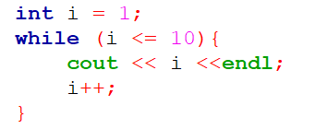

**While loop for test cases:**

**Infinite Loop:**

**For Overflow and Data types:**

-10^9 < int < 10^9

-10^12 < long int < 10^12

-10^18 < long long int < 10^18

Double, float e number er accuracy / precision valo hoy na tai use kori na.

**Continue statement**

Break jemon ber kore ney, continue opposite vabe ferot jay

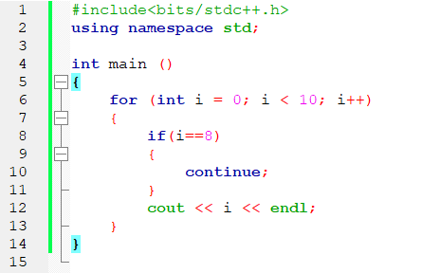

Getting each element of a STRING

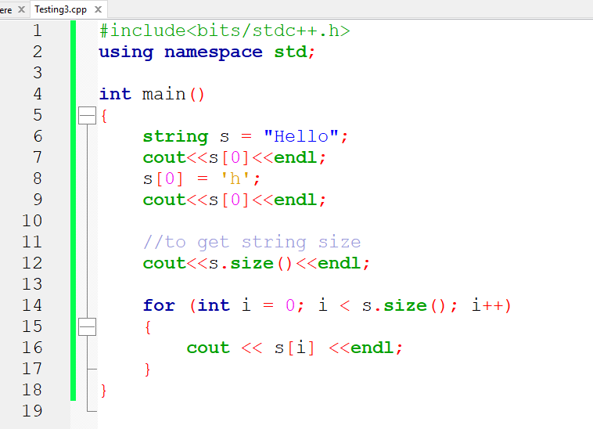

Eksathe 2 ta string input and eksathe output:

Jodi amra ei spacewala 2 ta string eksathe ekta string e output dekhate chai:

But jodi majhe onk space thake, shekhetre getline() function use korbo jeta whole line read korbe:

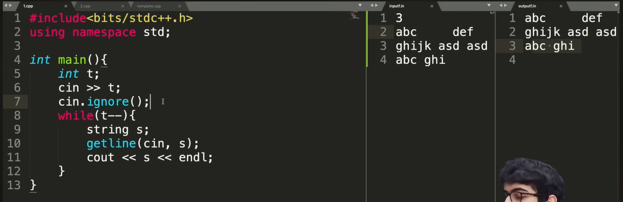

**Reverse String save and Show korar jonno:**

But evabe time complexity onk bere jabe. Echara amra string e char add korchi jeta thik na.

Etar solution hocche .push_back() use kora jay jeta ekta ekta character niye add korbe and same output dibe

**String Palindrome kina checking:**

Palindrome bolte shuru theke porleo jemon ashbe shesh theke porleo temon e ashbe

Ex: aabaa, acbdbca

String reverse kore just string ta reverse string er shoman kina ota check korlei hobe

Dealing With Large Number using String:

Jodi emon hoy je amk 10^18 er o beshi onk bishal ekta number input dilo.. tokhon sheta amra string e input nite pari ….. kintu shekhetre amader prottekta digit number hishebe extract kore nite hobe.

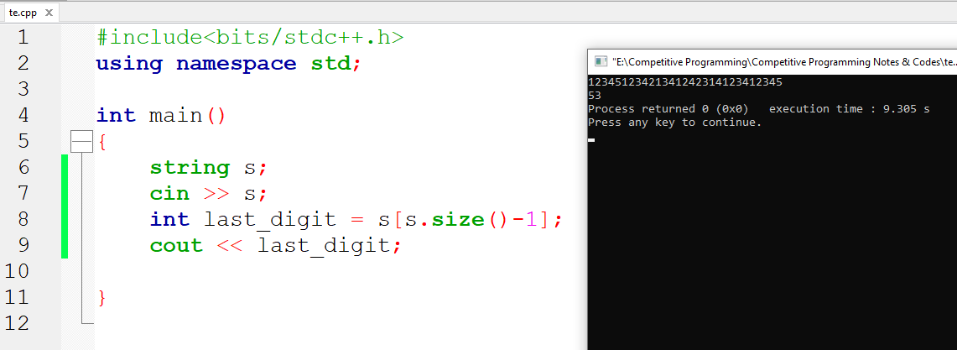

Ekhane last_digit e 5 er ASCII value save hoise. Eta int value hishebe pete ‘0’ diye minus korte hobe.

**2D and nD Array**

Int a[4]

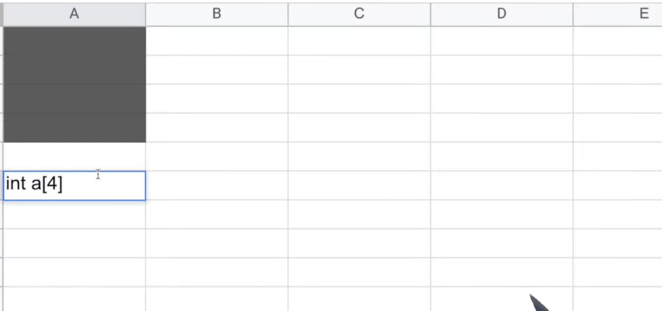

Int a[4][3]

2D Array:

**Add characters in any String : Two Ways : BETTER way described:**

Way 1 is better as time complexity is less

